**Deliverable 3: Model Building**

This folder will have all the data models which gives insights.

**# Analysis of data:**

1. **Countries with Highest Covid cases:**

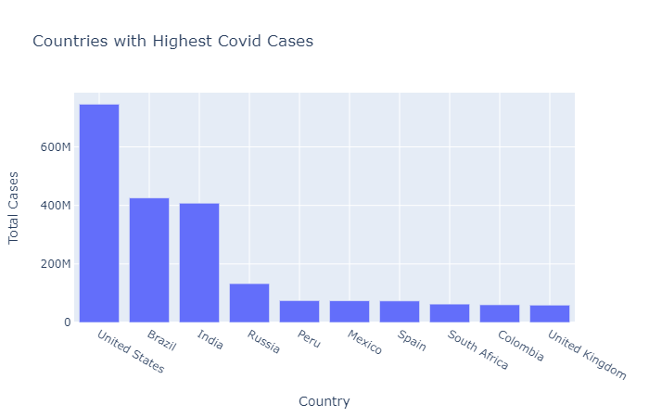

1. **Countries with Highest deaths:**

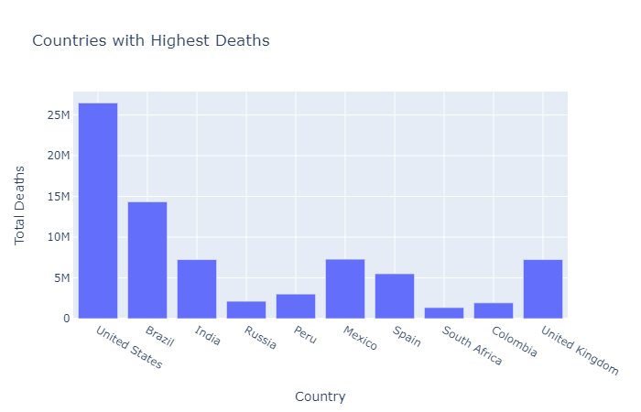

1. **Comparison cases and deaths:**

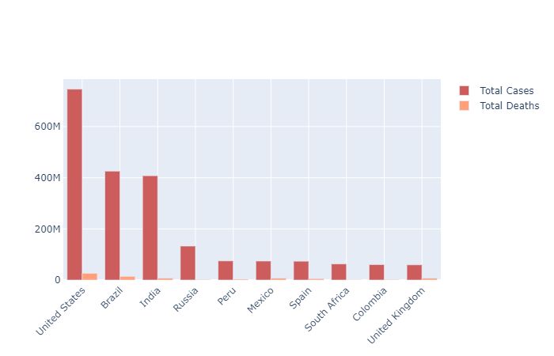

1. **Percentage of total cases and deaths:**

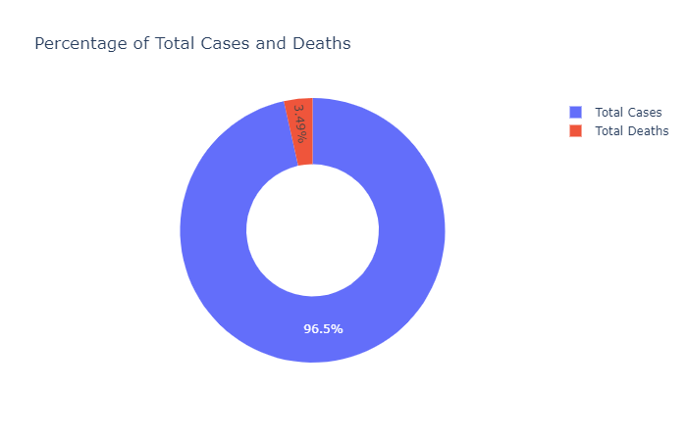

1. **Covid impacts on Economy:**

* **GDP per Capita before covid:**

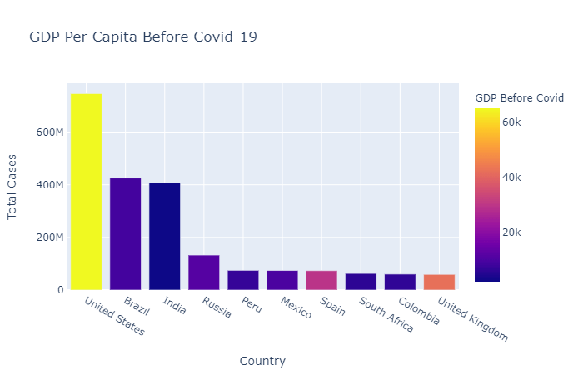

* **GDP per Capita during covid:**

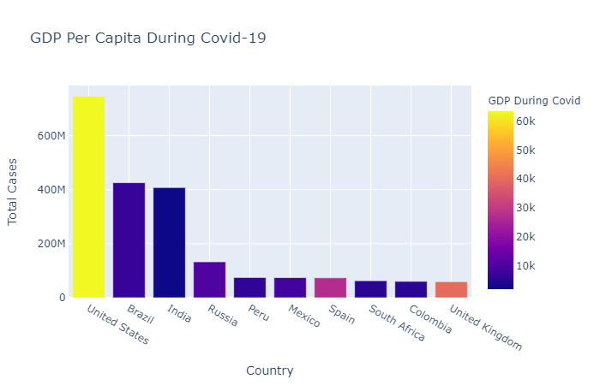

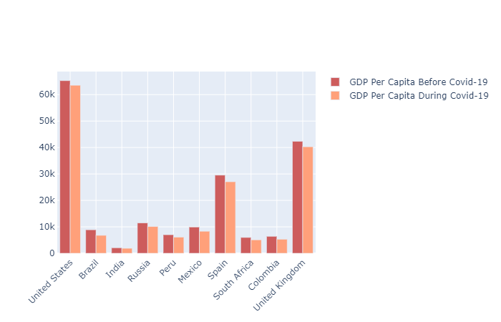

* **Human Development Index during covid:**

